6. Git status (to know current status)

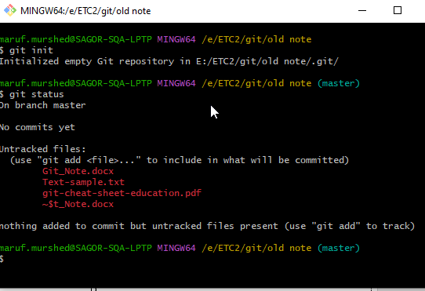

7.Some untracked file found in red color

8. To add any specific file use ‘git add’ comment, Ex: git add Git_Note.docx

-Then show the status using Git status

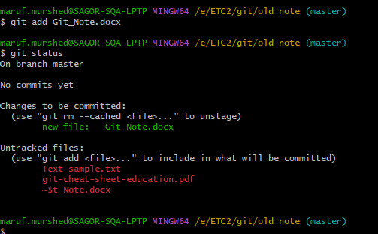

1.**Download** Git from Google and then **install.**

2.After Install **Right click** on mouse and will find ‘Git GUI’ and ‘Git Bash Here’ option

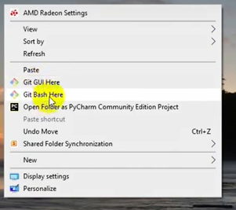

3.Click on ‘Git Bash Here’, a cmd black promot here,type git --version, to get current version information.

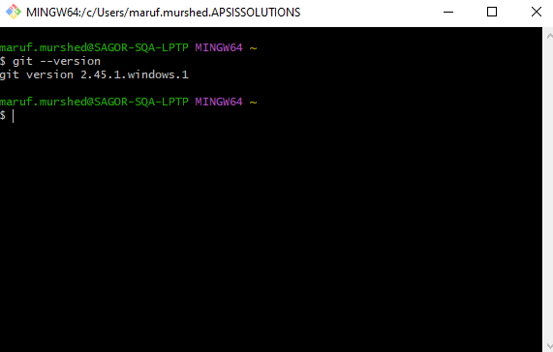

4.Open the project folder and right click on mouse>Click Git Bash here

5. Type Git init (a .git file will add on that folder)

tex

iooooooooooooooooooooooooooooooooooooooooooooooooooooooooooooooooooooo

9.To add all those files on one comment **Git add – all /git add . (Then check the status)**

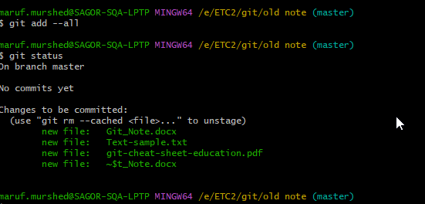

10.To commit those all into local repo

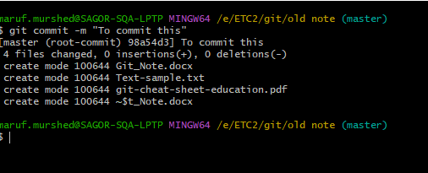

11. To create Remote Repo, Goto Github.com>Profile>Repositories>New

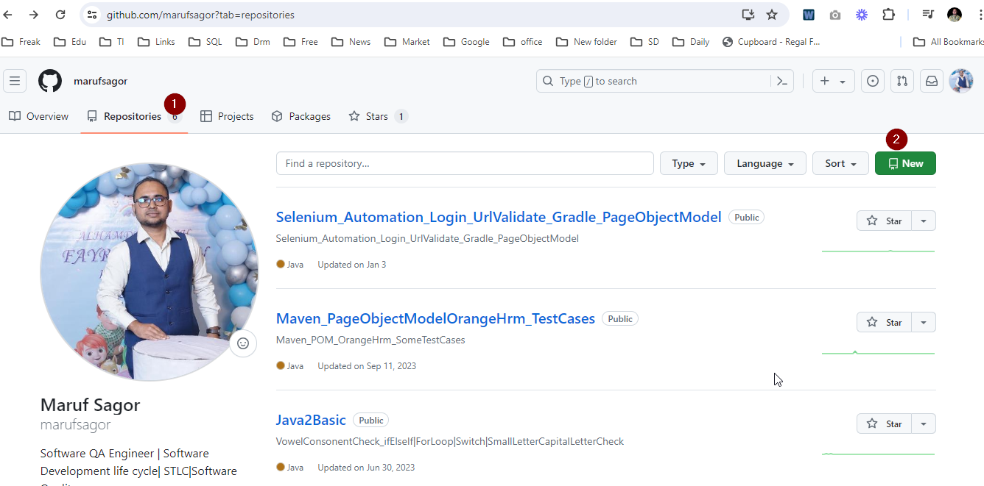

9.To add all those files on one comment **Git add – all /git add . (Then check the status)**



10.To commit those all into local repo



11. To create Remote Repo, Goto Github.com>Profile>Repositories>New



O

# 12. Create a new repository

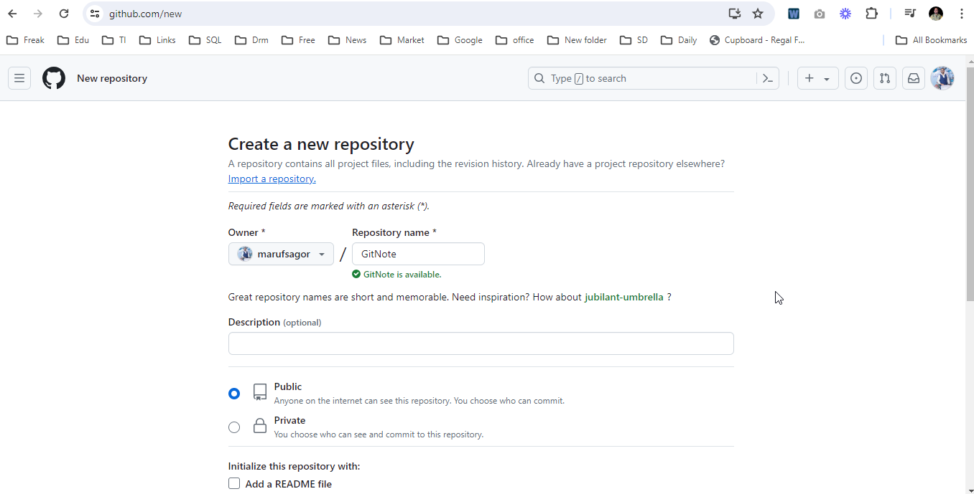

**13. Copy from github web ,and paste it to cmd as before>Enter**

**git remote add origin** [**https://github.com/marufsagor/GitNote.git**](https://github.com/marufsagor/GitNote.git)

**14. git push -u origin master**

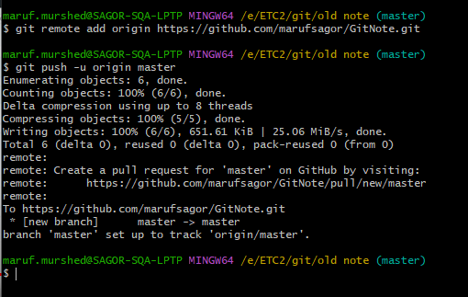

**15.Reload the URL will get latest upload file**

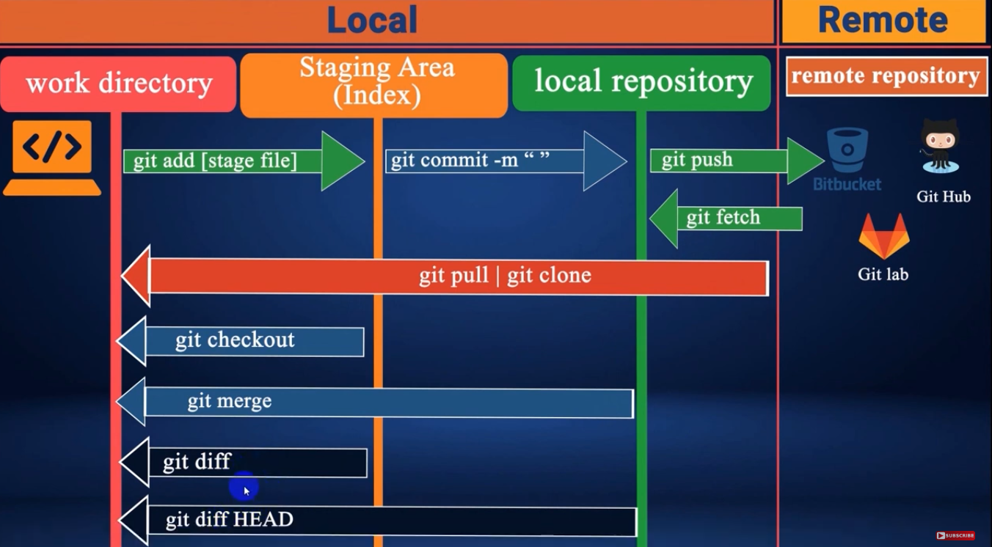

o